[Insert Patient Name Here]
[Insert Patient Identifier Here]

Dear Mr./Mrs./Ms. [Patient Last Name],
[Insert Facility Name] is excited to announce that we now offer our patients the option of choosing Sedation-Free Transnasal Endoscopy for the evaluation, screening, and diagnoses of conditions of the Upper Gastrointestinal Tract.

What is Sedation-Free Transnasal Endoscopy (TNE)?
Sedation-Free Transnasal Endoscopy (TNE) is a safe and efficient alternative to transoral endoscopy that does not require general anesthesia or sedation. The endoscope used is narrow and flexible, allowing your doctor to look at your digestive system via your nose. Sedation-free TNE eliminates any potential complications associated with general anesthesia.

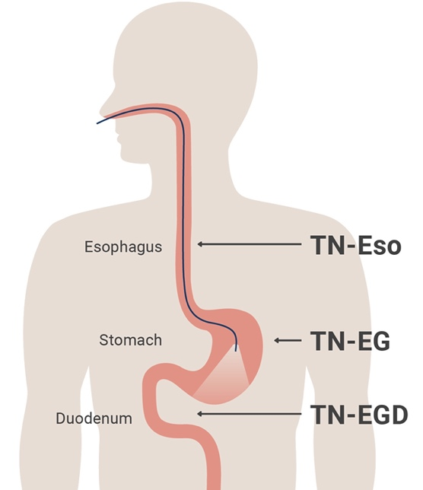
What will happen?
- A numbing agent will be applied to your nasal passages to help numb your nose and the back of your throat.
- The endoscope is inserted through the nose and can be advanced down through the esophagus (food pipe), stomach, and part of the small intestine (duodenum).
- If needed, very small samples of tissue called biopsies may be taken through the endoscope using special forceps. Air and water may also be used to make it easier for the doctor to see.

Have more questions?
Please reach out to [Insert Preferred Contact Method & Information Here] for more information regarding risks, benefits, scheduling, and whether or not this procedure might be a good option for you or your loved one.

[Insert Signature/Facility Footer Here]

