

Law Enforcement Sales
Tom Jankiewicz– Executive Vice President
Matt Farkas– Senior Director (East of Mississippi)
Thomas Mechling– Director (West of Mississippi)
Dave Jones – Director (Canada)
Scott Reidy – Director of LE Training

REGIONAL SALES CONTACTS
First and Last Name | Region | Title | Email | Phone | Sales Assignment
Andrew Delorey | 1 | Regional Manager | andrew.delorey@sigsauer.com | 603-339-6760 | ME, NH, VT, MA, CT
Adam Culbertson | 2 | Regional Manager | Adam.Culbertson@sigsauer.com | 610-931-7422 | NY, PA
Rich Verdi | 3 | Regional Manager | rich.verdi@sigsauer.com | 732-614-8542 | NJ, DE, MD
John Sheppard | 4 | Regional Manager | john.sheppard@sigsauer.com | 804-908-0649 | NC, SC, VA, WV
Dave O'Connor | 5 | Regional Manager | david.oconnor@sigsauer.com | 407-416-9474 | AL, GA, MS, TN
Dave Hinkell | 6 | Regional Manager | david.hinkell@sigsauer.com | 603-801-5580 | FL
Rob Bilacic | 7 | Regional Manager | robert.bilacic@sigsauer.com | 616-638-6761 | MI, OH
George Smith | 8 | Regional Manager | George.Smith@sigsauer.com | 812-454-4192 | IN, IL, KY
Paul Braun | 9 | Regional Manager | Paul.Braun@sigsauer.com | 612-900-7151 | IA, MN, ND, SD, WI
Dave Ruble | 10 | Regional Manager | david.ruble@sigsauer.com | 785-407-0161 | AR, KS, MO, OK, MT, NE, WY
Jordan VanEnkevort | 11 | Regional Manager | jordan.vanenkevort@sigsauer.com | 775-203-6793 | N. TX, LA
Todd Rassa | 12 | Regional Manager | todd.rassa@sigsauer.com | 410-967-6314 | S. TX
Jason Bledsoe | 13 | Regional Manager | jason.bledsoe@sigsauer.com | 503-500-2667 | WA, OR, ID
John D'Agostini | 14 | Regional Manager | john.d'agostini@sigsauer.com | 530-306-0653 | N. CA, N. NV
Josh Curci | 15 | Regional Manager | joshua.curci@sigsauer.com | 619-971-6516 | S.CA, S. NV
Robert Feigenspan | 16 | Regional Manager | Robert.Feigenspan@sigsauer.com | 808-864-6734 | AZ, CO, NM, UT
Lou Graziano | 21 | Territory Representative | louis.graziano@sigsauer.com | 845-248-4930 | NYC, Nassau, Suffolk, Westchester

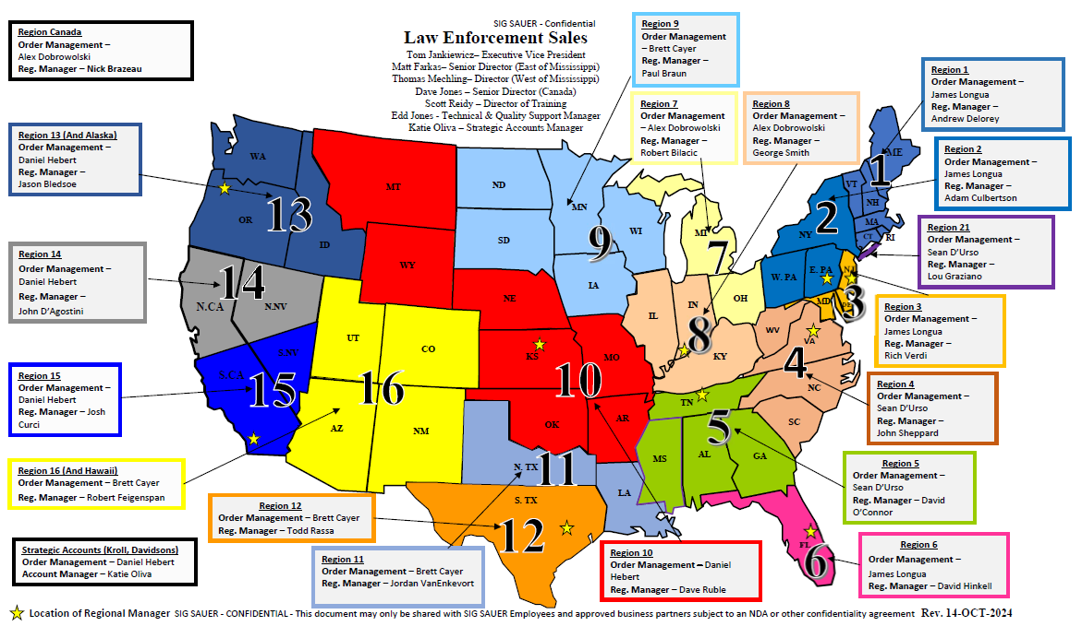
USE THE FOLLOWING MAP TO LOCATE SALES CONTACTS BY REGION
SIG LAW ENFORECEMENT DISTRIBUTOR (SLED)

SLED Information | Territory | Phone | Website | Email
Atlantic Tactical | Maine, New Hampshire, Vermont, Massachusetts, Rhode Island, Connecticut, New York, Pennsylvania, New Jersey, Delaware, Maryland, Virginia, North Carolina, South Carolina | 800-781-2677 | www.AtlanticTactical.com
Lawmen's Distribution, LLC. | Maryland, Virginia, West Virginia, North Carolina, South Carolina | 800-426-3486 | www.Lawmens.com
Dana Safety Supply | Florida, Georgia, South Carolina, North Carolina, Montana, Wyoming | 800-845-0045 | https://danasafetysupply.com
Proforce Law Enforcement | Alaska, Washington, Oregon, Idaho, Montana, Wyoming, Colorado, Utah, Nevada, California, Arizona, New Mexico, Hawaii, Texas, Oklahoma | 800-367-5855 | www.proforceonline.com | sales@proforceonline.com
Acme Sports | Illinois, Indiana, Kentucky, Michigan, Wisconsin, Missouri | 812-522-4008 | https://www.acmesportsinc.com
Accurate Law Enforcement | Arkansas, Mississippi and Tennessee | 901-774-9595 | https://www.accuratelawenforcement.com
Sentinel Supply | Arkansas, Kansas, Louisiana, Missouri, Nebraska, Oklahoma, Texas | 281-455-7177 | www.sentinel-supply.com | Quotes@sentinel-supply.com
Gulf States Distributors | Mississippi, Alabama, Georgia, Florida Panhandle | 334-271-2010 | www.gulfstatesdist.com
Streichers | Iowa, Illinois, Minnesota, Wisconsin, North Dakota, South Dakota, Nebraska, Missouri | 800-367-3763 | www.streichers.com
Vance Outdoors | Indiana, Kentucky, Michigan, Ohio, West Virginia | 614-471-0712 | www.vanceoutdoors.com
Federal Firearm | Delaware | 302-300-0590 | www.federalfirearm.com
Firing Line, Inc. | Pennsylvania, Maryland, Delaware | 215-336-1710 | www.phillytacticalgunsales.com | lesales@firinglineinc.com
H&H Shooting Range | Oklahoma | 405-947-3888 | https://www.hhshootingsports.com/shop/
Sticks and Stones | California | 951-234-9159 | https://www.sticksandstonesarms.com/ | chris@sticksandstonesarms.com
Sturgis Guns | North Dakota, South Dakota | 605-561-4867 | www.sturgisguns.com
Big Rock Sports, LLC | Canada | 800-663-1442 |  | custserv.help@bigrocksports.com
M.D. Charlton | Canada | 250-652-5266 | Sig Sauer products carried by MD Charlton Co Inc, Canada

