

Law Enforcement Sales
Tom Jankiewicz– Executive Vice President
Matt Farkas– Senior Director (East of Mississippi)
Dave Jones – Senior Director (Canada)
Thomas Mechling– Director (West of Mississippi)
Scott Reidy – Director of LE Training
Katie Oliva – Strategic Accounts Manager

REGIONAL SALES CONTACTS
First and Last Name | Region | Title | Email | Phone | Sales Assignment
Andrew Delorey | 1 | Regional Manager | andrew.delorey@sigsauer.com | 603-339-6760 | ME, NH, VT, MA, CT, RI
Adam Culbertson | 2 | Regional Manager | Adam.Culbertson@sigsauer.com | 610-931-7422 | DE, NY, NJ, PA
John Sheppard | 4 | Regional Manager | john.sheppard@sigsauer.com | 804-908-0649 | MD, NC, SC, VA, WV
Dave O'Connor | 5 | Regional Manager | david.oconnor@sigsauer.com | 407-416-9474 | AL, GA, MS, TN
Dave Hinkell | 6 | Regional Manager | david.hinkell@sigsauer.com | 603-801-5580 | FL
Rob Bilacic | 7 | Regional Manager | robert.bilacic@sigsauer.com | 616-638-6761 | MI, OH
George Smith | 8 | Regional Manager | George.Smith@sigsauer.com | 812-454-4192 | IN, IL, KY
Paul Braun | 9 | Regional Manager | Paul.Braun@sigsauer.com | 612-900-7151 | IA, MN, ND, SD, WI
Dave Ruble | 10 | Regional Manager | david.ruble@sigsauer.com | 785-407-0161 | AR, KS, MO, OK, MT, NE, WY
Brian Frick | 12 | Regional Manager | brian.frick@sigsauer.com | 806-282-4573 | TX
John D'Agostini | 14 | Regional Manager | john.d'agostini@sigsauer.com | 530-306-0653 | N. CA, N. NV, OR, WA
Josh Curci | 15 | Regional Manager | joshua.curci@sigsauer.com | 619-971-6516 | S. CA, AZ
Robert Feigenspan | 16 | Regional Manager | Robert.Feigenspan@sigsauer.com | 808-864-6734 | S. NV, CO, NM, UT, ID
Lou Graziano | 21 | Regional Manager | louis.graziano@sigsauer.com | 845-248-4930 | NYC, Nassau, Suffolk, Westchester

USE THE FOLLOWING MAP TO LOCATE SALES CONTACTS BY REGION
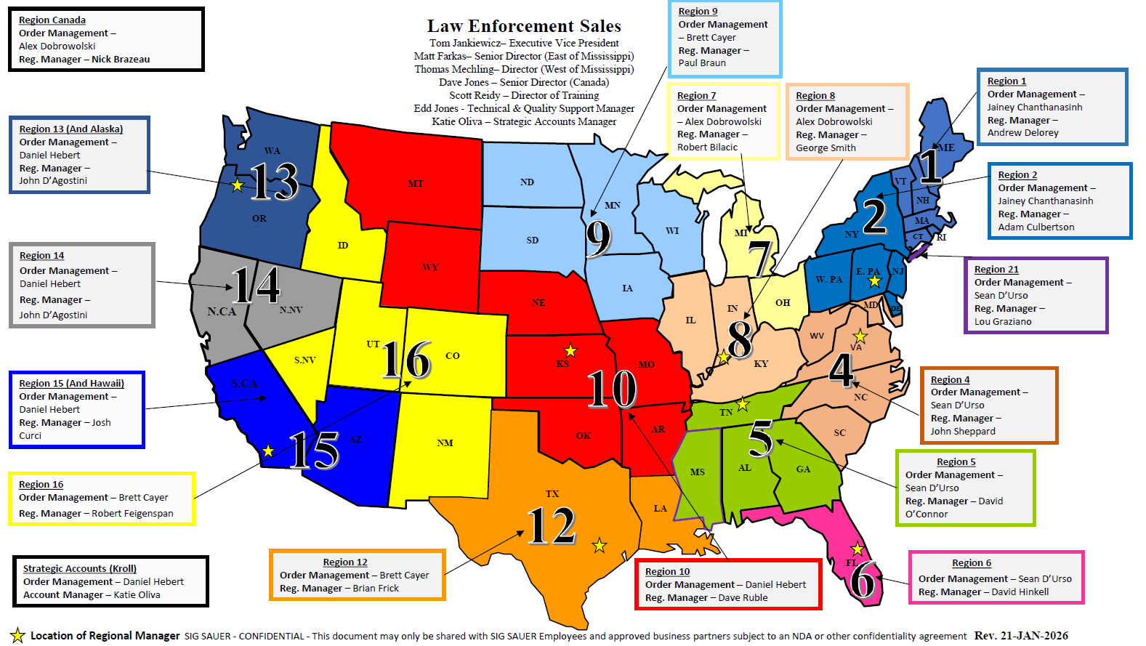
SIG LAW ENFORECEMENT DISTRIBUTOR (SLED)
SLED Information | Territory | Phone | Website | How to Contact
Atlantic Tactical | Maine, New Hampshire, Vermont, Massachusetts, Rhode Island, Connecticut, New York, Pennsylvania, New Jersey, Delaware, Maryland, Virginia, West Virginia, North Carolina, South Carolina | 800-781-2677 | www.AtlanticTactical.com  https://www.atlantictactical.com/store-locations/ | https://www.atlantictactical.com/contact-us/
Dana Safety Supply | Florida, Georgia, South Carolina, North Carolina, Montana, Wyoming | 800-845-0045 | https://danasafetysupply.com
Proforce Law Enforcement | Alaska, Washington, Oregon, Idaho, Montana, Wyoming, Colorado, Utah, Nevada, California, Arizona,  New Mexico, Hawaii, Oklahoma | 800-367-5855 | www.proforceonline.com | sales@proforceonline.com
Acme Sports | Illinois, Indiana, Kentucky, Michigan, Wisconsin, Missouri | 812-522-4008 | https://www.acmesportsinc.com | https://www.acmesportsinc.com/contact-us
Accurate Law Enforcement | Arkansas, Mississippi and Tennessee | 901-774-9595 | https://accuratelawenforcement.com/home | https://accuratetacticalmemphis.com/contactus  sales@accuratelawenforcement.com
Sentinel Supply  DBA CTC Gunworks, LLC | Arkansas, Kansas, Louisiana, Missouri, Texas, Oklahoma | 713-936-1970 Option 2 | https://sentinel-supply.com | https://sentinel-supply.com/contact-us/  info@ctcgunworks.com
Gulf States Distributors | Mississippi, Alabama, Georgia, Florida Panhandle | 334-271-2010 | https://gsdles.com/ | https://gsdles.com/contact/
Vance Outdoors | Indiana, Kentucky, Michigan, Ohio, West Virginia | 614-471-0712 | https://www.vanceoutdoors.com/category.cfm/outdoors/law-enforcement | https://www.vanceoutdoors.com/contact_us.cfm
Federal Firearm | Delaware | 302-300-0590 | www.federalfirearm.com | https://www.federalfirearm.com/contact
Firing Line, Inc. | Pennsylvania, Maryland, Delaware | 215-336-1710 | www.phillytacticalgunsales.com | lesales@firinglineinc.com
H&H Shooting Range | Oklahoma | 405-947-3888 | https://hhshootingsports.com/shop/ | Contact H&H Shooting Sports: Gun Range & Shop in OKC
Sticks and Stones | California | 951-234-9159 | https://www.sticksandstonesarms.com/ | chris@sticksandstonesarms.com
M.D. Charlton | Canada | 250-652-5266 | Sig Sauer products carried by MD Charlton Co Inc, Canada

