






MCA | Corporate Overview
Leading An Industry and Building A Legacy
Industry Leading Voice, Data, and Security Solutions

We believe every workplace should be safe, secure, and efficient. As trusted advisors, we deliver integrated communication, connectivity, and security solutions with a Service-First mindset, driven by a team that cares deeply about our customers and each other.
Why MCA? At MCA, we help solve critical communication, connectivity, and security challenges with turnkey, integrated system solutions—from two-way radios and in-building wireless to video surveillance, access control, and more. MCA is built from over 50 companies with deep technical expertise and strong local roots. And we’re still growing—expanding our capabilities, our reach, and our team.
With decades of experience, MCA stands as the nation’s premier integrator of voice, data, and security solutions. As we continue to grow, our strength is built upon a diverse legacy and the collective expertise of our high-performance teams. This deep foundation enables us to deliver tailored strategies that support government, enterprise, and commercial operations, guided by our unwavering commitment to trust, competence, and leadership.
Our 100+ Solution Centers bring together sales, installation, service, and customer operations teams to deliver seamless, nationwide support.
Guided by our Service-First values, we don’t just connect the wires and walk away—we provide customized solutions backed by deep expertise and lifecycle support.
The Nation’s Premiere Integrator of Safety and Communications Technologies

Two-Way Radios and Radio Infrastructure
Mobile and Body-Worn Video Solutions
Fleet Management and Vehicle Upfitting
Enterprise Wired and Wireless Communications
Mass Notification, Life Safety, and Alarm Systems
Video Surveillance, Access Control, and Detection Systems
Ecosystem Management and Monitoring
Custom Integrations and Software Applications


The MCA Way | Service-First DNA > Teamwork > Safety > Growth

30+ Years
1,700+ Employees 20+ States 100+ Offices 50+ Acquisitions
One Team
One Vision









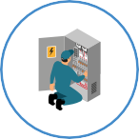







© 2025 | Mobile Communications America
MCA Corporate Overview

MCA is committed to delivering results that go beyond providing technical solutions. Whether your business is navigating stringent compliance needs or seeking to modernize aging communication infrastructure, our expert teams ensure that every solution is more than just robust technology — it is a strategic answer to pressing business and mission-critical challenges.

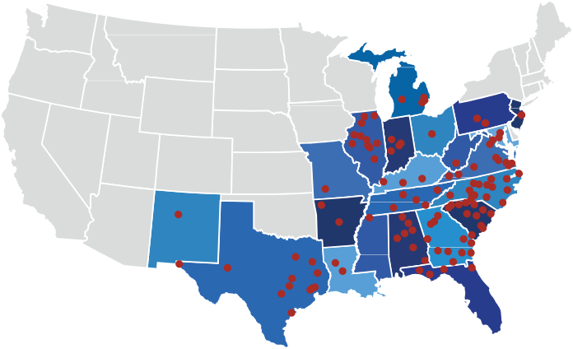
Our customers rely on us because we approach every engagement as a partnership—delivering not only robust technologies but also comprehensive support that extends throughout the life of your solution. By leveraging modern systems and proven processes, we ensure your organization is well-equipped to overcome evolving operational challenges and maintain peak security and connectivity.
We look forward to the opportunity to work with our customers, sharing our dedication to excellence and ensuring that their buildings, grounds, and team members remain safe, secure, and efficient.

Delivering Excellence with a Tailored Approach
The “Service-First mindset” that underpins our operations means we actively strive to make every step of the solution lifecycle seamless. Our certified teams are with you from the initial consultation through installation, ongoing support, and comprehensive maintenance. For organizations that seek long-term partnerships with professionals they can trust, MCA represents a team dedicated to solving even the most complex requirements with unmatched precision.
We don’t just solve problems; we anticipate them. By proactively maintaining systems and continuously enhancing our service offerings, we enable operational continuity for our customers. From avoiding costly downtimes to optimizing workflows, MCA ensures that every investment in our solutions delivers measurable outcomes.
























Trusted Partnerships Backed by Local Expertise
Our expansive network of over 50 integrated companies reflects deep roots in communities across the country. With strong relationships built from years of trust and collaboration, MCA combines localized knowledge with national reach. This allows us to provide our customers with unparalleled responsiveness—even in industries with highly specialized demands such as manufacturing, healthcare, and public safety.
This localized expertise is combined with the expansive capabilities of our growing number of solution centers, which house fully integrated sales, service, and operational teams. Whether it's designing an in-building wireless system for a corporate office or implementing advanced video surveillance for a secure government facility, our dedicated professionals deliver both strategic and tactical value at every stage.

Beyond Technology—Empowering Your Workforce
What does success look like for your organization? For MCA, success is more than achieving operational benchmarks—it’s empowering every individual and team within your organization. Whether we’re equipping facilities with advanced access control systems to protect staff and visitors or deploying a suite of communication tools to enhance cross-team collaboration, MCA creates environments where people and operations thrive.
This approach extends beyond installations. Through ongoing training sessions, troubleshooting assistance, and lifecycle management solutions, MCA equips your teams with the tools and confidence they need to leverage technology effectively. When everyone on your team feels secure, connected, and supported, your entire organization stands to achieve its fullest potential.

A Partnership That Prioritizes Your Success
“What does it mean to be an integrator? An innovator? What does it mean to put customers first?” For MCA, these questions define our commitment to excellence. Our teams are trained not only to implement technologies seamlessly but also to listen to your needs. Every engagement is built on an understanding of your unique operational goals, allowing us to tailor solutions that go beyond just functionality to deliver true impact.
We take pride in our ability to help customers achieve success in practical ways. For some, this might mean reducing downtime by implementing reliable communication networks. For others, it might mean eliminating vulnerabilities with state-of-the-art security systems.
No matter the challenge, MCA’s customers can trust our teams to respond with expertise, ensuring that every aspect of their workplace is ready for today—and tomorrow.

A Carefully Curated Portfolio of Solutions
MCA offers a portfolio designed specifically to meet the needs of modern organizations. From two-way radio communication networks that ensure clear dialogue across teams to AI-enhanced detection systems that deter threats before they arise, our solutions are as innovative as they are reliable. We invest heavily in researching and refining our offerings, curating technologies that address the specific challenges faced by businesses, schools, municipalities, and more.
We also understand that solutions are only as effective as the people and workflows they support. That’s why MCA doesn’t just sell products—we create comprehensive strategies that combine reliable solution deployments with long-term sustainability. Our customers can operate with confidence, knowing
they have future-ready solutions that can scale and adapt to evolving challenges.

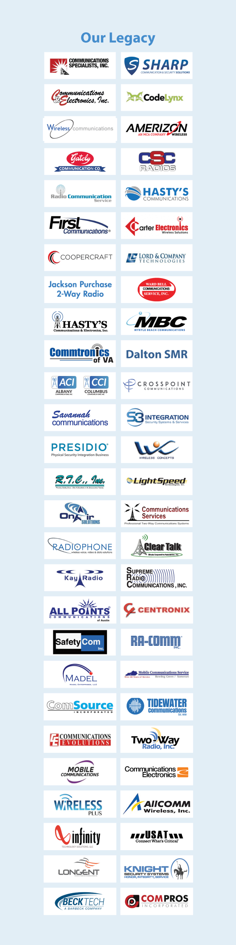

© 2025 | Mobile Communications America MCA Corporate Overview

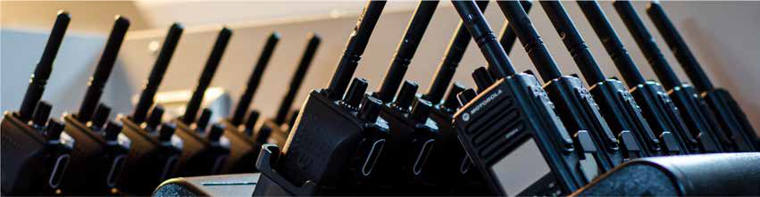

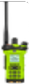
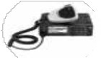
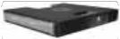
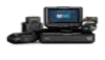
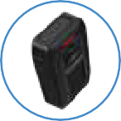
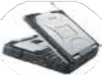
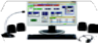

Hand Radios
Mobile Radios
Radio Systems
Dispatch
Fleet Cameras
Body Cameras
Computers
Voice Solutions

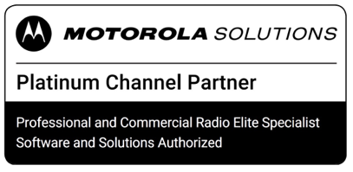

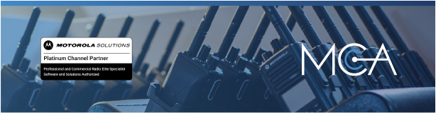

MCA’s Voice Division delivers cutting-edge voice communication and mobility solutions designed to enhance connectivity, efficiency, and safety across a wide range of industries. Our comprehensive portfolio includes business and mission-critical two-way radio systems, integrated mobile video platforms, and custom vehicle upfitting services. Each solution is engineered to improve operational awareness, streamline coordination, and strengthen field capabilities. As a Motorola Platinum Level Channel Partner, we uphold the highest standards of quality and reliability.
- Two-Way Radios: We offer a full spectrum of portable and mobile two-way radios tailored for both public safety and commercial environments. Supported by conventional and advanced trunked radio systems, our solutions ensure dependable, real-time communication in critical situations. Integrated with robust dispatch platforms, these systems enable seamless coordination between field teams, dispatch centers, and command staff.
- Mobile Video Solutions: Our portfolio features body-worn cameras, in-vehicle camera systems, and drone-based solutions. These platforms provide real-time situational awareness, secure evidence collection, and operational transparency for law enforcement, emergency response, and commercial applications. Integrated with industry-leading video management software, our solutions enable synchronized evidence management and advanced analytics to drive investigative efficiency.
- Vehicle Upfitting: We specialize in seamlessly integrating mobile voice, video, and data systems into first responder vehicles, utility service fleets, and commercial transports. Our up-fitting services include the installation of PA systems, radars, cameras, equipment mounts, storage solutions, and advanced mobile computing and communication hardware such as cellular routers and in-vehicle radios. Each build is meticulously designed for durability, ergonomic efficiency, and peak performance in the field, ensuring your teams are equipped to excel in any environment.
With decades of industry expertise and a strong partnership with Motorola Solutions, MCA delivers voice communication systems that set the standard for performance and reliability. Whether equipping first responders, optimizing fleet communications, or enabling secure mobile video capture, our solutions are purpose-built to enhance operational readiness and safety in any environment.
•
Two-Way Radios
- Handheld Radios
- Mobile Radios
- Radio Accessories
- Equipment Rentals
Two-Way Radio Infrastructure
- Conventional Radio Systems
- Trunked Radio Systems
- Single and Multi-Site Systems
- ASTRO P25 Systems
- MOTOTRBO Systems
- Standalone Repeaters
•
Radio Dispatch Systems
- Consoles and Workstations
- 9-1-1 PSAP Applications
- Dispatch Applications
- Dispatch Accessories
- Incident Management
- Call Logging and Recording
- Records and Evidence Mgmt
Mobile Video Solutions
- Body-Worn Cameras
- Vehicle Cameras
- License Plate Recognition
- Drone Management Applications
▪
Video Management Systems
•
Fleet Upfitting
•
•
- Mobile Radio, Router, and Antenna Installations
- Mobile Computing Devices
- Rugged Laptops
- PA and Speaker Systems
- Vehicle Lighting
- Equipment Mounts
- Storage Boxes and Trays
- Radar Equipment
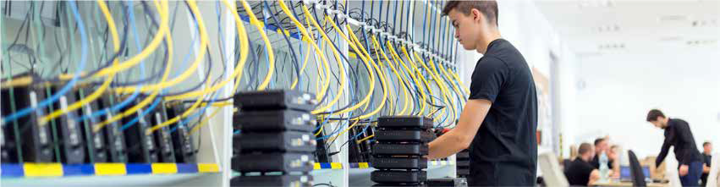
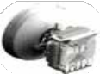
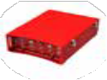
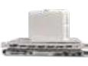
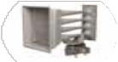
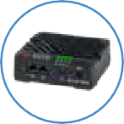
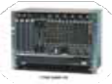
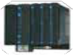

Public LTE/5G
Private LTE/5G
Microwave
ERRCS / DAS
IP-MPLS
Notification
SCADA
Data Solutions



MCA’s Data Division delivers robust, secure, and scalable communications systems built to meet the demands of industries ranging from critical infrastructure and public safety to enterprise and commercial operations. Our solutions are engineered for reliability, ensuring uninterrupted connectivity and high-performance data transmission in environments as varied as remote industrial sites and dense metropolitan areas.
- Cellular Networking Solutions (CNS): Purpose-built for IoT applications, branch offices, and mobile operations, our CNS portfolio includes ruggedized antennas, routers, modems, and wideband adapters. These systems ensure dependable connectivity in environments where traditional networks are unavailable or unreliable.
- In-Building Wireless Solutions (IWS): Comprehensive in-building coverage through Public Safety DAS (ERRCS/ERCES), Cellular DAS, and Private Wireless (PLTE/5G) networks. Leveraging advanced components like Bi-Directional Amplifiers (BDA), Distributed Antennas, Remote Radios, and Small Cells, our solutions enhance safety and operational efficiency for first responders, staff, and the public.
- Network Infrastructure Solutions (NIS): High-speed, mission-critical backbones integrating Microwave, Fiber Optical, and IP-MPLS technologies. Scalable by design, these solutions empower organizations to expand capacity and capabilities in line with evolving business and operational needs.
- Mass Notification Systems (MNS): Critical alert systems ranging from wide-area outdoor sirens to networked indoor speakers and integrated software platforms. Designed for rapid, targeted communication, these systems keep communities, campuses, and industrial sites informed and protected when seconds matter most.
- Supervisory Control and Data Acquisition (SCADA): Advanced solutions for remote monitoring and precise control of distributed assets. SCADA systems empower operators to automate processes, improve safety, and respond instantly to changing conditions across industrial and utility environments.
With MCA, clients gain more than technology—they gain a strategic partner. Our certified engineers and technicians combine industry-leading products with deep technical expertise to deliver communication systems that solve today’s challenges while anticipating tomorrow’s demands. From design and deployment to ongoing support, we ensure your connectivity, operations, and critical data remain secure, efficient, and future-ready.
•
Cellular Networking
- Rugged Routers, Modems, and Wideband Adapters
- Customized NEMA Enclosures, Cabling, and Antenna Systems
Private Wireless Networks
- Small Cells and Radio Nodes
- Private SIMS and Core Networks
- Evolved Packet Cores (EPC)
•
In-Building Wireless Solutions
- Public Safety ERCES / LMR
- Cellular (Neutral-Host) DAS
Broadband Infrastructure
- Microwave Backhaul Transport
- Fiber Optical (XGS-PON / FTTH)
- IP Networking and MPLS Routing
- Data Center Solutions
- Network and Fault Management
•
•
•
Mass Notification Systems
- Sirens, Speakers, and PA’s
- Visual Lighting and Beacons
- Device Activation Management
- SCADA Systems
  - Remote Terminal Units
  - Edge Gateways
  - Fire Station Automation
  - HMI and Software Integrations

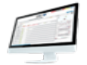
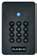
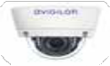
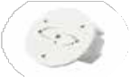
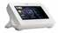
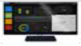
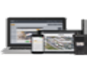
Surveillance
Access Control
Detection
Alarms
Software
Integrations
Management
Security Solutions


MCA’s Security Division delivers advanced solutions designed to safeguard people, property, and critical infrastructure with precision and reliability. Taking an integrated approach, we combine leading-edge technologies into tailored systems that address the unique security and operational challenges faced by each client. Engineered for scalability and resilience, our solutions ensure your security infrastructure remains adaptable in a continually evolving threat landscape.
- Video Surveillance: Our systems leverage the latest advancements in imaging, analytics, and video management to provide clear, actionable intelligence. With 360-degree coverage and advanced recognition capabilities such as facial and license plate identification, we ensure comprehensive situational awareness. We offer a range of advanced cameras including options with edge computing for real-time analytics, thermal detection for enhanced monitoring, and explosion-proof housings for maximum safety and durability in hazardous areas.
- Access Controls: MCA delivers advanced access control solutions, ranging from electronic and biometric locking systems to robust physical barriers such as turnstiles, gates, and bollards. Integrated visitor management platforms streamline entry processes, automate credentialing, and maintain comprehensive access logs for audit and compliance, ensuring secure facilities without compromising operational flow or efficiency.
- Detection Systems: Our technologies are built for proactive threat identification and response, stopping risks before they escalate. We offer solutions capable of detecting perimeter breaches, facility intrusions, motion, vibration, visible firearms, concealed weapons, contraband, and audible threats—such as sounds of violence or cries for help. Additionally, we provide tools for smoke and vapor analysis, drone monitoring in restricted airspace, and advanced environmental systems to identify chemical, biological, radiological, and nuclear (CBRN) hazards. These comprehensive solutions safeguard against both traditional and emerging threats.
With decades of proven experience, MCA is a trusted partner dedicated to enabling organizations to operate with confidence. From initial system design and implementation to ongoing support, our team brings together industry-leading technologies and deep technical expertise, ensuring your security infrastructure not only protects but also strengthens compliance and supports long-term operational success.
•
Video Surveillance
- Intelligent Cameras
- Camera Mounts and Installs
- Storage and AI Applications
- Management Platforms
- Command and AV Centers
Access Control
- Electronic Locking Hardware
- Electronic Barriers (Gates, Turnstiles, and Bollards)
- Control Panels and Hubs
- Intelligent Intercoms
▪
▪
▪
▪
Visitor Management Systems Employee Credentialing Insider Threat Mitigation Advanced Biometrics
- Alarm Systems
- Air, Sea, and Ground Radar
- Anti-Drone (UAV/UAS) Systems
▪
Smart Sensors
- Management Platforms
•
Detection Systems
•
•
- Intrusion Detection and Perimeter Monitoring
- Acoustical, Visual, and Touchless Weapon Detection
- Intelligent Access Controls
- AI-Enhanced Surveillance
Integrations and Management
- Software Development
- Third-Party Integrations
- Augmented Reality
- Cybersecurity Consulting
- Remote Monitoring and Management (SecurePlan)
- System Health Monitoring (Sentry)



MCA delivers a comprehensive suite of services designed to optimize your technology infrastructure, enhance operational efficiency, and uphold the highest standards of security. Our approach is rooted in understanding and meeting the complex needs of each client, including those with stringent regulatory requirements and demanding operational environments. With a legacy of excellence, we partner with organizations to ensure their technology investments deliver lasting value and reliability.
- Professional Services: Our services are integral to the deployment of full-scale technology solutions. Our team goes beyond simple product sales, offering expert consulting to ensure the right products are selected for each unique environment. We oversee every step—system design, proper installation, thorough configuration, and
post-deployment validation—so your systems operate precisely as intended. Our services provide comprehensive project oversight, compliance auditing, user training, site surveys, and meticulous performance benchmarking, ensuring each solution is tailored, implemented, and tested to the highest professional standard.
- Managed Services: Our Managed Services let organizations offload technology oversight to our expert team, with support defined by Service Level Agreements (SLAs) that outline inspection schedules, repair or maintenance requests, and annual system tune-ups. Through our Managed Technology-as-a-Service (MTaaS) model, MCA fully owns the technology lifecycle—providing, maintaining, repairing, and upgrading equipment as part of a seamless service. SecurePlan delivers proactive monitoring of equipment activity, enabling remote diagnostics, software updates, and equipment resets, with rapid technician dispatch if needed. These services maximize uptime, reduce operational burdens, and ensure fast, dependable support.
- Integrated Solutions: Expert integration is offered as an extension of our Professional Services, connecting newly deployed systems with legacy infrastructure. By designing unified management platforms and automating workflows, we streamline operational oversight and create centralized points of control for disparate technologies. This approach enables seamless communication, unified security and incident responses, improves process automation, and reduces complexity—empowering organizations to more efficiently and confidently manage their technology environments.
With a team that holds active security clearances, UL 2050 SCIF certifications, and extensive field experience, MCA is uniquely qualified to deliver solutions in environments requiring the utmost security and compliance. Our expertise also extends to supporting projects for the Department of Defense, Department of Energy, Homeland Security, and in highly specialized settings such as confined spaces, clean rooms, and AART cleaner zones.

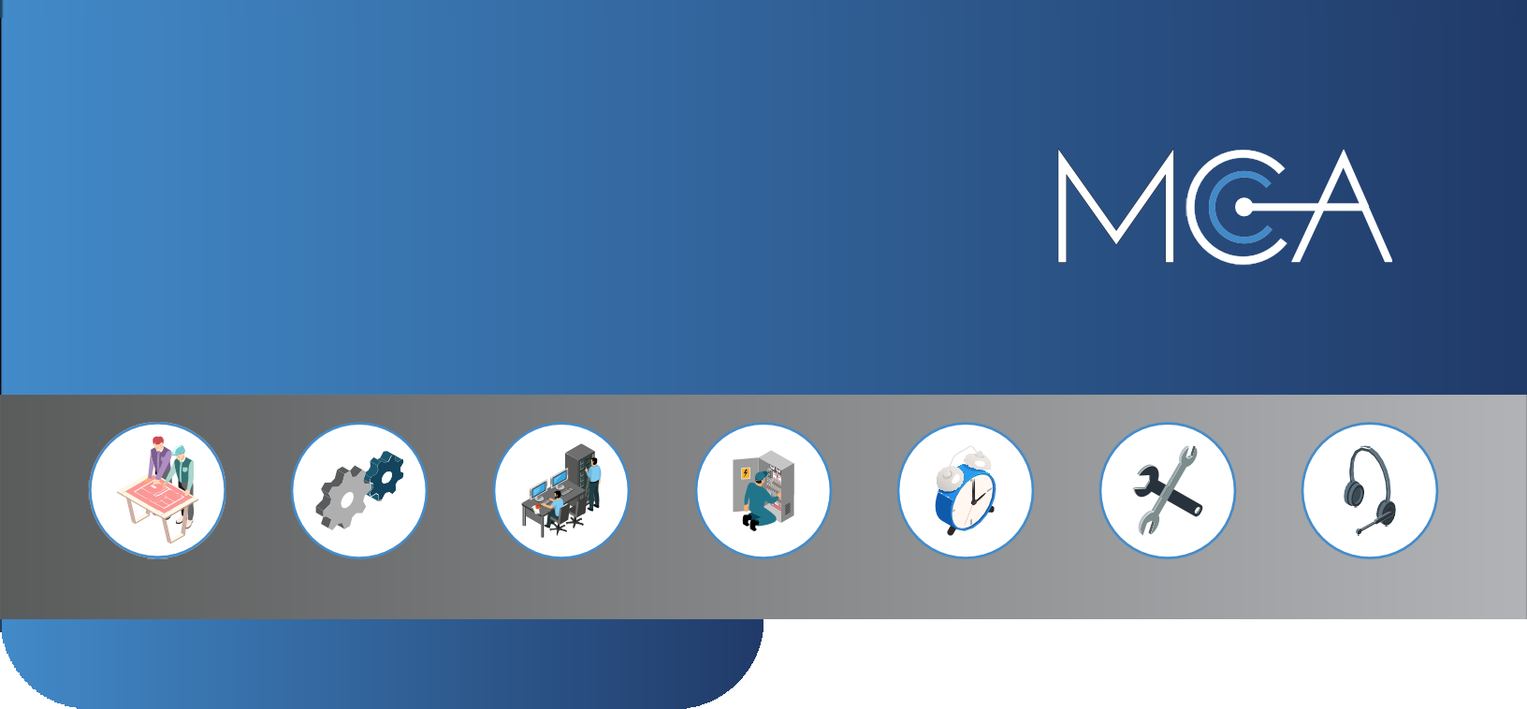

  - Professional Services
Consulting
Engineering
Staging
Installation
Management
Maintenance
Support
Life-Cycle Services
    - Provisioning & Configuration
    - Engineering & Design
    - Implementations & Installations
    - Surveying & Benchmarking
    - Staging & Proof of Concept
    - Project Management
    - Compliance & System Audits
- Managed Services
  - Service Level Agreements (SLAs)
  - Managed Technology as a Service (MTaaS)
  - MCA SecurePlan™ and Sentry™ Security Monitoring
  - Microwave Network Assurance Program (MNAP)
- Integrated Solutions
  - Workflow Automation
  - Incident Management
  - Work Order Ticketing
  - Unified Management Systems
  - Custom Applications
  - Software Development
  - Third Party Integrations

IN SUMMARY
At MCA, we redefine excellence by delivering a comprehensive suite of communication and security technologies that empower organizations to thrive in an ever-evolving landscape. From public safety systems and private commercial radio to mass notification, cellular networking, surveillance, access control, and detection systems, we provide solutions that are as innovative as they are reliable.
For decades, MCA has been a trusted leader, uniting the expertise of over 50 companies to create a legacy of innovation and service. Our solutions are not just about technology—they are about enabling connectivity, enhancing operational efficiency, and safeguarding the people and places that matter most. Every client’s unique challenges are met with tailored strategies designed to deliver measurable results and long-term success.
Our team of skilled engineers and technicians brings unparalleled expertise to every project, ensuring that our systems are robust, reliable, and ready to meet the demands of any operation. Whether supporting first responders in critical moments, enhancing corporate environments, or securing high-risk areas, MCA’s solutions are built to perform when it matters most.
From the first consultation to ongoing support, MCA is more than a service provider—we are your partner in progress. With a steadfast commitment to reliability, customer satisfaction, and technological advancement, we prepare you not just for today’s challenges but for the opportunities of tomorrow. Together, let’s transform the way the world communicates and secures, creating a safer, more connected future for all.
>> Contact Us Today
OUR CUSTOMERS



Public Safety
Education
Hospitality
Healthcare
Logistics
Manufacturing

Federal
Public Venues
Construction Retail & Branch
Transportation
Utilities

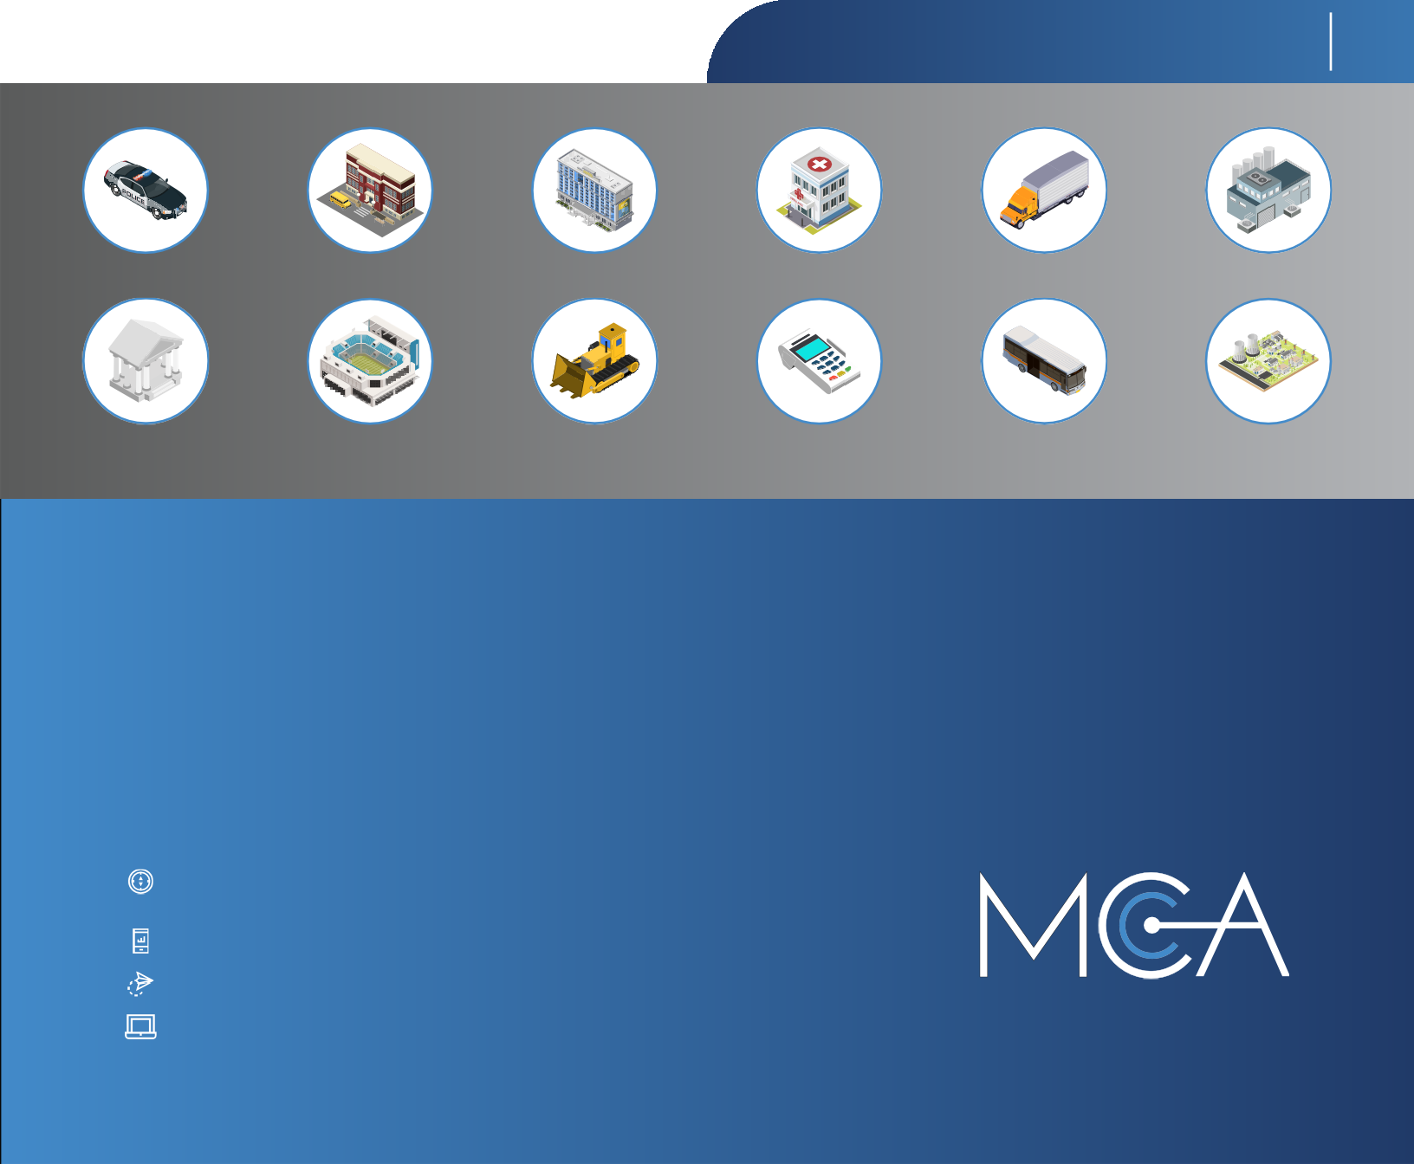

MCA Headquarters
135 N Church St #310
Spartanburg, SC 29306
800.596.8205
info@callmc.com www.callmc.com

